UEXT SUMMER UNIVERSITY 2024
4 - 14 June, 2024
Universidad Externado de Colombia, Bogotá, D. C.

COURSE INFORMATION
COURSE NAME | Sustainable Development: A Global Perspective
SCHEDULE | 4 – 14 June, 09h:00 – 12h:00 (Monday through Friday) Classroom contact
ROOM | TBC
HOURS PER DAY | 3
TOTAL HOURS | 40
MAX. NUMBER OF STUDENTS | 50
ONLINE MASTER CLASS | Thursday, June 6, 17h:00 – 18h:00  Topic: Sustainable Development
COURSE DESCRIPTION | Course aim: This course provides an integrated overview of sustainable development from a global perspective, with the aim of conceptualizing how sustainable development can be achieved in government, business, and society. Students are introduced to the global and national debates and will examine the origins, scientific evidence, issues, policies, political and legal processes, as well as the obstacles to achieving sustainable development. The interdisciplinary approach highlights the need for a balance between the environmental, economic, and social dimensions (“the three pillars”) of sustainable development through an analysis of the indicators, trends, and changing patterns of consumption, production, and distribution of resources. Case studies demonstrate the concepts and principles of sustainable development and how they might be incorporated into national and international development projects.  Course content: Economic development has, in recent times, been achieved at the expense of degraded natural systems, diminished resources, changes to the climate, loss of biodiversity, and increased health risks from pollution. Sustainable Development (SD) is a key challenge for the present generation so that its needs can be met without compromising the ability of future generations to meet their needs. The solutions are complex and will require coordinated interaction by governments, local communities, businesses, institutions, and non-governmental organizations. SD thus requires a systematic focus on environmental protection, stewardship of resources, achieving business models for shared economic benefit, working with communities and households to support social progress, and a change of attitude, awareness, behaviour, and lifestyle. The syllabus for this course will critically review the plethora of SD definitions and associated key concepts (intergenerational equity, the growth paradigm, the closed loop cycle, precautionary principle); compare the movement toward sustainability in different world regions and countries; and analyse the environmental, economic and social dimensions of sustainable development; International examples on globalization (communications, international trade), poverty alleviation (foreign aid, women’s empowerment), economic measures of progress and SD indicators, urban and local food production, and resource use (industrialization, pollution, climate change) provide insight into ); goals and strategies for sustainable development, the roles of public and private enterprises, and professional and social responsibilities.  Suggested readings: The 2030 Agenda for Sustainable Development’s 17 Sustainable Development Goals (SDGs) https://sdgs.un.org/sites/default/files/2020-09/SDG%20Resource%20Document_Targets%20Overview.pdf  Urban Sustainability: A Global Perspective, edited by IGOR VOJNOVIC, 2013, Published by: Michigan State University Press  https://www.jstor.org/stable/10.14321/j.ctt130hjhm  Transforming Our World: The 2030 Agenda For Sustainable Development  https://sustainabledevelopment.un.org/content/documents/21252030%20Agenda%20for%20Sustainable%20Development%20web.pdf  The 2030 Agenda and the Sustainable Development Goals An opportunity for Latin America and the Caribbean  https://repositorio.cepal.org/server/api/core/bitstreams/6321b2b2-71c3-4c88-b411-32dc215dac3b/content  Sustainable Development Goals (SDGs) Selected Online Resources  https://unric.org/en/wp-content/uploads/sites/15/2020/01/sdgs-eng.pdf
LECTURER’S BIO
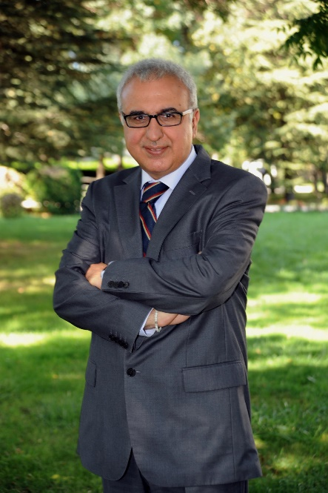  Dr. Bulent Acma, PhD  Anadolu University  Turkey | Dr. Acma received a Ph.D. Degree from the Department of International Economics and Economic Development, Istanbul University. He is currently working as a researcher and lecturer at Anadolu University, Turkey as well as chair of the economy department. TRANSFORMING OUR WORLD: THE 2030 AGENDA FOR SUSTAINABLE DEVELOPMENT.  He has been in the UK as a visiting professor at the University of Exeter, University of Birmingham, University of Southampton, as well Research Fellow at the Regional Science Association International and awarded FeRSA status. Also, he has held research positions in some Baltic Universities (Estonia, Lithuania, and Latvia) universities.  He has more than published 50 articles, in international peer-reviewed journals, and SSCI (Social Sciences Citation Index) and SCI (Science Citation Index), 5 books and reports.

