UEXT SUMMER UNIVERSITY 2024
4 - 14 June, 2024
Universidad Externado de Colombia, Bogotá, D. C.

COURSE INFORMATION
COURSE NAME | AI Horizons: Exploring the Depths of Large Language Models
SCHEDULE | 4 – 14 June, 09h:00 – 12h:00 (Monday through Friday) Classroom contact
ROOM | TBC
HOURS PER DAY | 3
TOTAL HOURS | 40
MAX. NUMBER OF STUDENTS | 50
ONLINE MASTER CLASS | Tuesday, June 11, 17h:00 – 18h:00  Topic: AI Horizons
COURSE DESCRIPTION | Artificial Intelligence stands at the forefront of technological innovation, fundamentally altering the landscape of all scientific fields. Central to this AI revolution are Large Language Models (LLMs) like GPT (Generative Pre-trained Transformer), which have demonstrated unprecedented capabilities in understanding, generating, and interpreting human language.  This course is designed to delve into the intricacies of these models, offering a comprehensive exploration of their operational frameworks, practical applications, and their broader societal impacts. The aim of this course is threefold:  - Practical Mastery of LLM Tools: Students will learn how to effectively utilize LLMs, transforming theoretical knowledge into practical competencies that can be applied across various domains.  - In-Depth Understanding of AI Mechanisms: Students will get a detailed understanding of the underlying mechanisms of LLMs, including their architectural design, training methodologies, and the algorithms that empower their linguistic capabilities and foster a deeper comprehension of their operational intricacies.  - Critical Analysis of AI's Future Trajectory: Engage in critical discussions and reflections on the potential future developments and implications of AI technologies, focusing on ethical considerations, societal impacts, and the potential for both positive transformations and challenges in a future shaped by AI.
LECTURER’S BIO
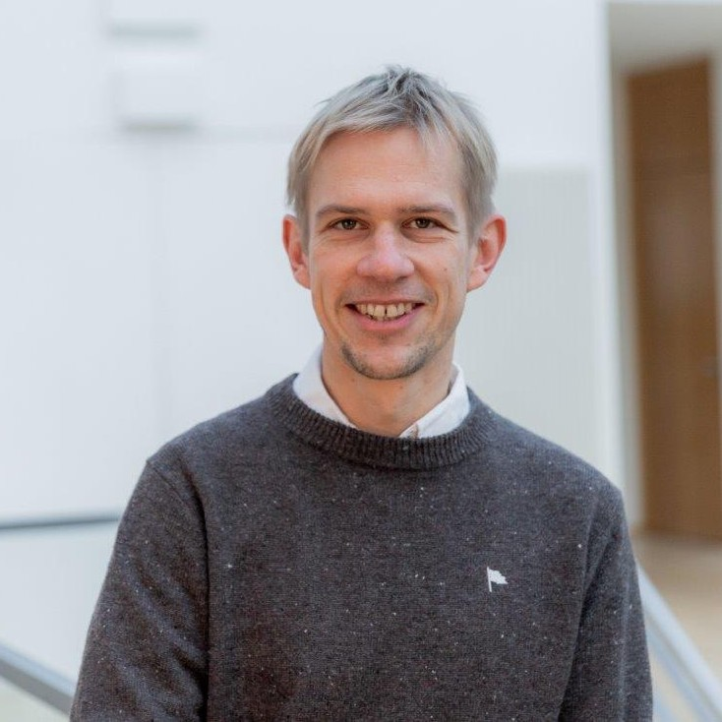  Prof. Dr. Jan Sölter,  Hochschule Stralsund – University of Applied Sciences  Germany | Prof. Sölter embarked on his academic journey in physics. His fascination with the intricate workings of the human brain led him to pursue a PhD in Computational Neuroscience, where he explored the intersection of computational models and neural processes. With this foundation, he ventured into the upcoming field of AI.  He's passionate about making AI understandable for everyone, not just tech experts. Since 2022, Prof. Sölter has been teaching and researching AI at Hochschule Stralsund, making the subject more accessible to a wider audience.

